### **Purpose**

Our purpose is to create an online tool where a host manages an in-person game and the players within that game, similar to Kahoot. The host is the narrator and creates a game, which others can join using a game PIN. The narrator has access to everything for running an in-person game. They can select which roles to include, receive direction for which roles go first in the nighttime portion of the game, and set a daytime timer to restrict the players from getting off-topic. The players can join a narrator's game, receive a role and a description for said role, select which players to apply the powers of their role to, vote for who to eliminate during the daytime, and view the daytime timer.

### **Design**

The project consists of two parts, the front end and the backend. The backend will keep track of current game sessions and players in a database and perform necessary logic for cross-device communication. The front end will display the various UIs for players to interact with the game either in the hosting role or player role.

### **Frontend**

All stages of the game will be displayed on separate web pages. The UI will be written using HTML and corresponding CSS files, along with JavaScript files to handle the logic and allow for dynamic displays. The frontend will also include basic animations and special visual effects in the final product.

### **Backend**

This layer is made up of a SQL database that stores game sessions and players with the necessary information and an express server that will receive HTTP requests for communicating with the database.

### **Full Stack**

The gameplay will be conducted in both the frontend and the backend. Player actions will be done in the frontend, then sent to the backend. The backend will update the game’s (and each player’s) status based on this information, and return said status to the frontend, which will affect the players’ abilities. This frontend-backend loop will be written in JavaScript, and will connect directly to the UI and database.

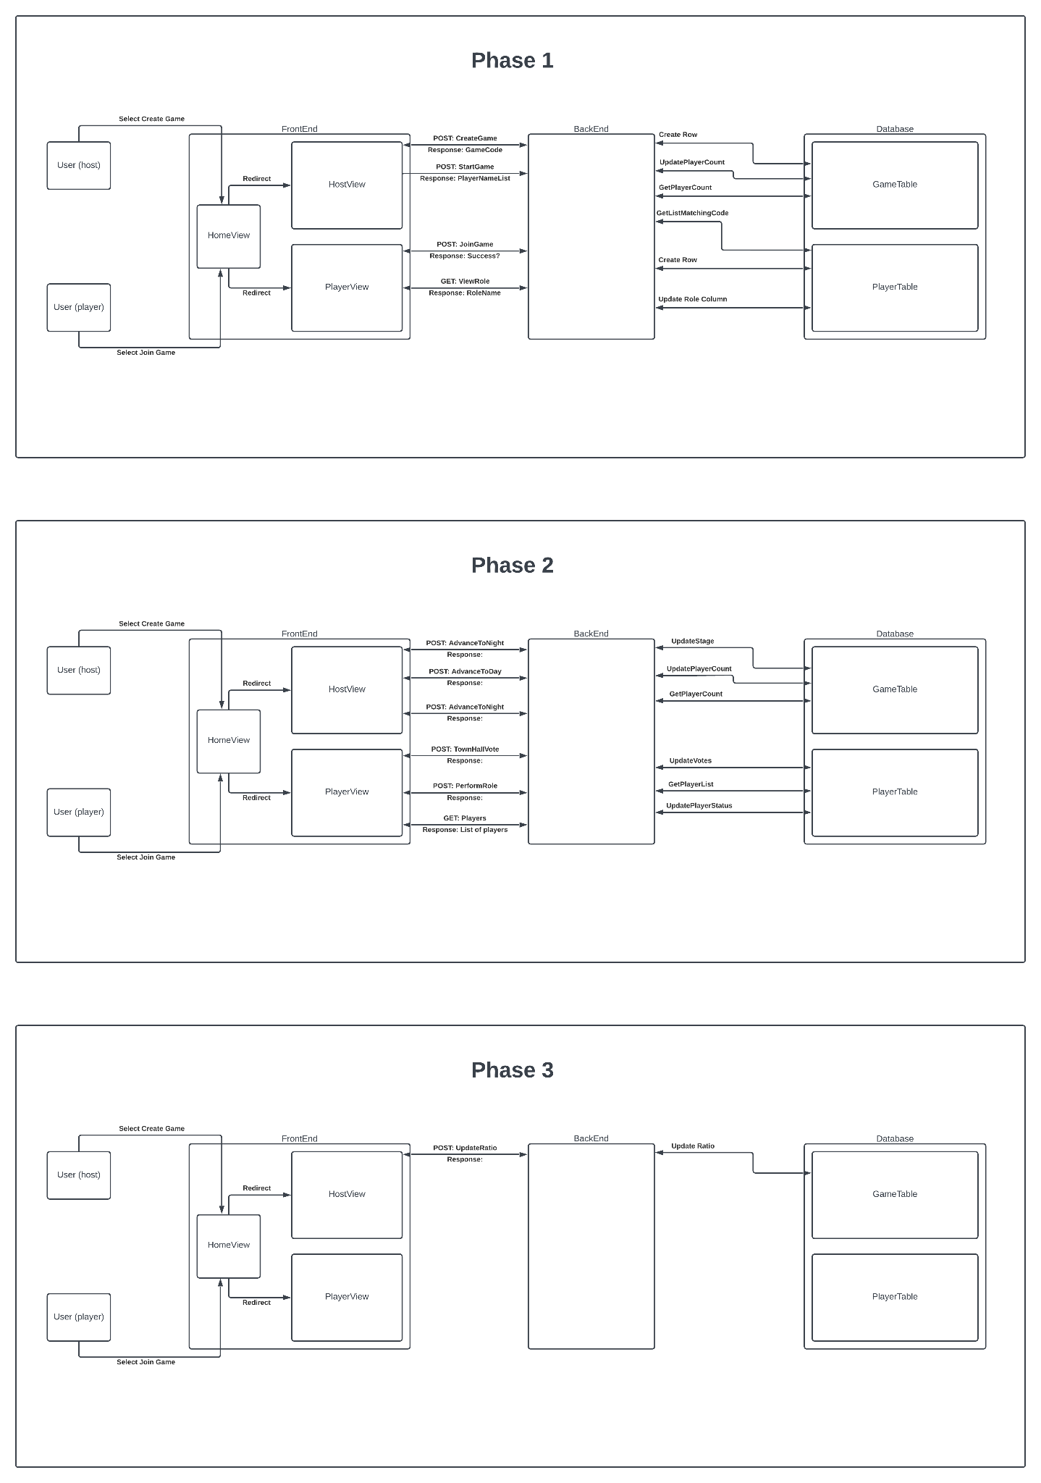

Note: Not all requests have been defined, but the general idea of communication for future phases can be found in the diagram.